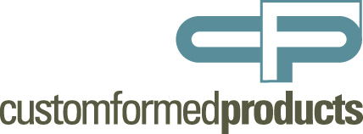

Foil Stamp Requirements and Guidelines for Overprinting of Foil:
- If your project requires that some printing is done prior to foil stamping, be sure to follow all of the procedures outlined on our foil stamping guidelines sheet.
- When printing on top of foil, be sure to use transparent, surface drying inks. Your ink company’s representative can give you advice on which inks will work best when printing on top of foil. Also, be aware some extra drying time may be required for the inks on top of the foil to cure completely.
- Large solid areas of foil should be avoided. If possible, try to foil stamp only the areas of the piece where the foil will be seen. If a large completely solid area is required, please contact your CFP representative immediately.
- Avoid reversing small type or thin lines out of blocks of foil. Please see our foil stamping guidelines sheet for recommendations on small type and thin line use in foil stamping.
- In addition to your art file and blank stock, we will require that you provide us with at least 300 “spotter” sheets. A spotter sheet is defined as press sheets that have all of the foil copy printed in black along with crop/trim marks, registration targets and any other marks that can be used to verify positioning on the sheet. We only want the foil copy printed. We will use these sheets to make ready with and to check registration throughout the run.
- Please be sure to give CFP plenty of extra stock for make ready and waste. For our operations, we request 150 sheets + 4-6% per operation. Don’t forget we’ll need to stamp overs for your printing make ready and waste. During the quoting phase of the project, please inform your CFP representative how many extra sheets you will require for printing and any other operation(s) you will be doing in house. That way, there are no shortages or possible extra cost due to a miscalculation of required spoilage.
- Be sure to clearly state how many sheets you will provide and how many sheets you expect back for your printing process on any POs associated with a foil overprint project.
- Overprinting foil on projects that are to be digitally printed is tricky business. CFP recommends you speak to your digital press’ manufacture about your intentions. Be sure to ask how hot the digital press gets during operation and if the toners, dyes, etc. will be compatible with hot foil stamping. Once that information is in hand we strongly recommend testing the process before production. Contact your CFP representative to schedule testing.

