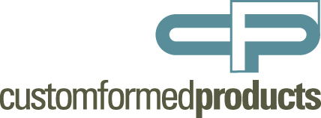

Artwork Requirements for Foil and Emboss Jobs:
Communication is key when producing a printed part with foil & embossing. To help us ensure your dies are correct and ordered without delay please review the following information. This will also assist with our foil and/or emboss being positioned correctly on your printed sheets. Please contact us should you have any questions.

Files Needed - We need two types of files:
- Imposed file of just what is being foil stamped or embossed. If your job requires both, please provide a file for each. This file will be used to order your dies with.
- Imposed file including your print elements. This file will be used to assist us with how your print registers with what we are stamping and/or embossing and will be used to help us set our dies correctly on press.

Digital File Specifications:
We suggest using: Adobe® Acrobat® pdf
We also accept Adobe® Illustrator®* (with layers)
* All fonts MUST be converted to outlines
When setting up your files, please:  - Do not include masks  - Convert all type to outlines  - Do not include compound paths  - All objects should be “filled”  - No intersecting lines  - Overprint selection is turned off | All artwork should be:  - 100% (actual size)  - Fully stepped out  - Vector art  - Saved at 600 dpi or higher  - All line art should display at 100% color; no screens or tints

